REST - Get country based on country code
Write a REST service that returns a specific country based on country code. The country code should be case insensitive.
Controller: com.cognizant.spring-learn.controller.CountryController
Method Annotation: @GetMapping("/countries/{code}")
Method Name: getCountry(String code)
Method Implemetation: Invoke countryService.getCountry(code)
Service Method: com.cognizant.spring-learn.service.CountryService.getCountry(String code)
Service Method Implementation:
- Get the country code using @PathVariable
- Get country list from country.xml
- Iterate through the country list
- Make a case insensitive matching of country code and return the country.
- Lambda expression can also be used instead of iterating the country list
Sample Request: http://localhost:8083/country/in
Sample Response:
{
"code": "IN",
"name": "India"
}
CountryController.java

package com.cognizant.spring_dn.controller;
import org.springframework.beans.factory.annotation.Autowired;
import org.springframework.web.bind.annotation.GetMapping;
import org.springframework.web.bind.annotation.PathVariable;
import org.springframework.web.bind.annotation.RestController;

import com.cognizant.spring_dn.Country;
import com.cognizant.spring_dn.service.CountryService;
@RestController
public class CountryController
{

@Autowired
private CountryService countryService;

@GetMapping("/countries/{code}")
public Country getCountry(@PathVariable String code)
{
return countryService.getCountry(code);
}
}

CountryService.java

package com.cognizant.spring_dn.service;
import java.util.List;
import org.springframework.context.ApplicationContext;
import org.springframework.context.support.ClassPathXmlApplicationContext;
import org.springframework.stereotype.Service;
import com.cognizant.spring_dn.Country;
@Service
public class CountryService
{

public Country getCountry(String code)
{

ApplicationContext context = new ClassPathXmlApplicationContext("country.xml");

@SuppressWarnings("unchecked")
List<Country> countries = (List<Country>) context.getBean("countryList");

return countries.stream()
.filter(c -> c.getCode().equalsIgnoreCase(code))
.findFirst()
.orElseThrow(() -> new CountryNotFoundException());
}
}

CountryNotFoundException.java

package com.cognizant.spring_dn.service;
import org.springframework.http.HttpStatus;
import org.springframework.web.bind.annotation.ResponseStatus;
@ResponseStatus(value = HttpStatus.NOT_FOUND, reason = "Country not found")
public class CountryNotFoundException extends RuntimeException
{

}

Country.java

package com.cognizant.spring_dn;

public class Country
{
private String code;
private String name;

public Country() {}

public String getCode()
{
return code;
}
public void setCode(String code)
{
this.code = code;
}

public String getName()
{
return name;
}
public void setName(String name)
{
this.name = name;
}

@Override
public String toString()
{
return "Country [code=" + code + ", name=" + name + "]";
}
}

SpringLearnApplication.java

package com.cognizant.spring_dn;
import org.slf4j.Logger;
import org.slf4j.LoggerFactory;
import org.springframework.boot.SpringApplication;
import org.springframework.boot.autoconfigure.SpringBootApplication;
import org.springframework.context.annotation.ImportResource;
@SpringBootApplication
@ImportResource({"classpath:country.xml"})
public class SpringLearnApplication
{
private static final Logger LOGGER = LoggerFactory.getLogger(SpringLearnApplication.class);

public static void main(String[] args)
{
SpringApplication.run(SpringLearnApplication.class, args);
LOGGER.info("Application started successfully");
}
}

Country.xml

<?xml version="1.0" encoding="UTF-8"?>
<beans xmlns="http://www.springframework.org/schema/beans"
xmlns:xsi="http://www.w3.org/2001/XMLSchema-instance"
xsi:schemaLocation="http://www.springframework.org/schema/beans http://www.springframework.org/schema/beans/spring-beans.xsd">

<bean id="countryIN" class="com.cognizant.spring_dn.Country">
<property name="code" value="IN" />
<property name="name" value="India" />
</bean>

<bean id="countryUS" class="com.cognizant.spring_dn.Country">
<property name="code" value="US" />
<property name="name" value="United States" />
</bean>
<bean id="countryDE" class="com.cognizant.spring_dn.Country">
<property name="code" value="DE" />
<property name="name" value="Germany" />
</bean>

<bean id="countryJP" class="com.cognizant.spring_dn.Country">
<property name="code" value="JP" />
<property name="name" value="Japan" />
</bean>

<bean id="countryList" class="java.util.ArrayList">
<constructor-arg>
<list>
<ref bean="countryIN"/>
<ref bean="countryUS"/>
<ref bean="countryJP"/>
<ref bean="countryDE"/>
</list>
</constructor-arg>
</bean>
</beans>

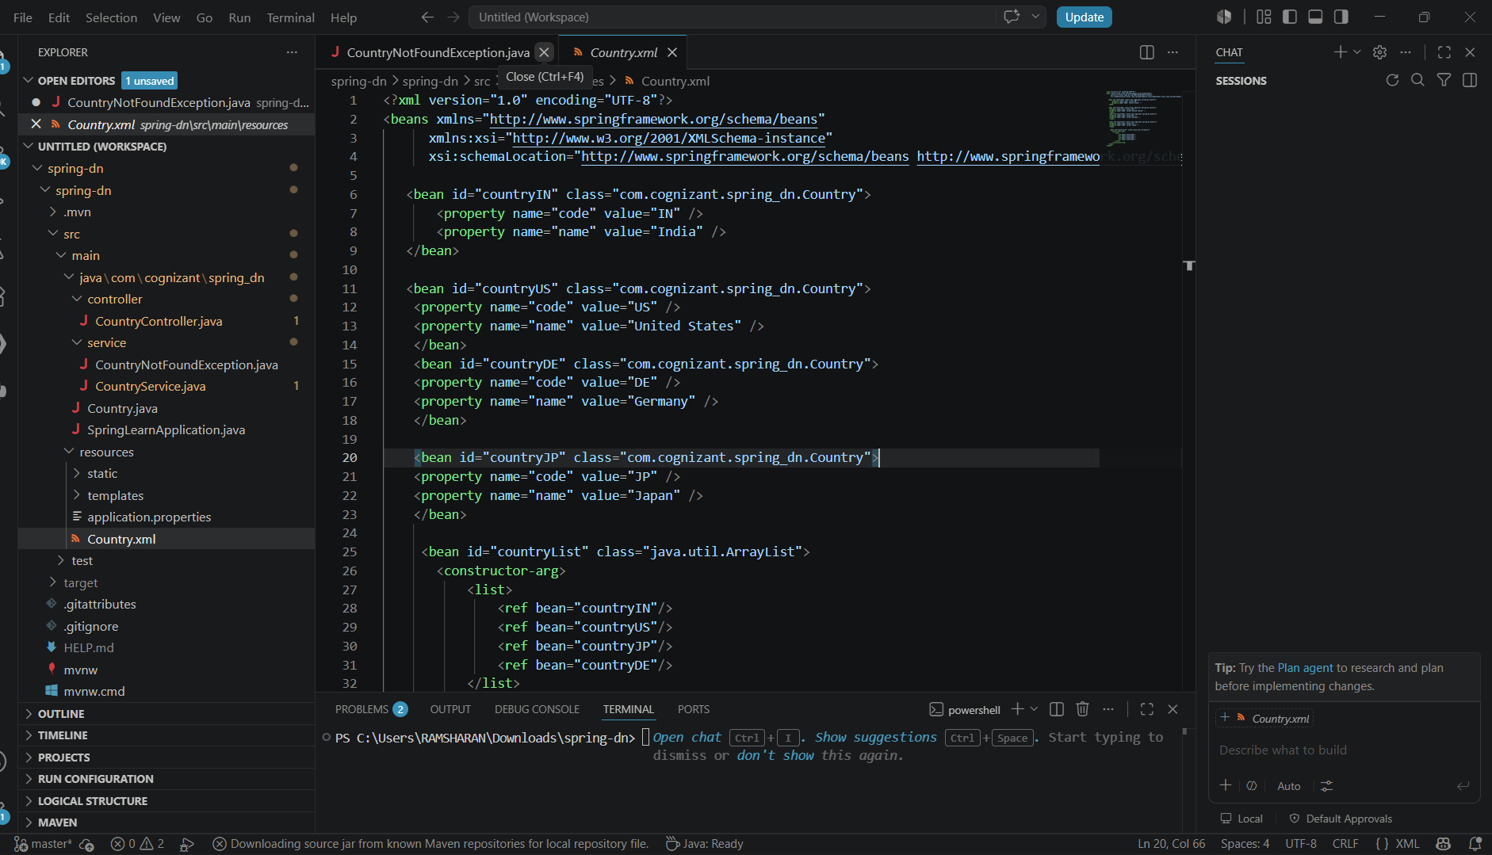
Output
